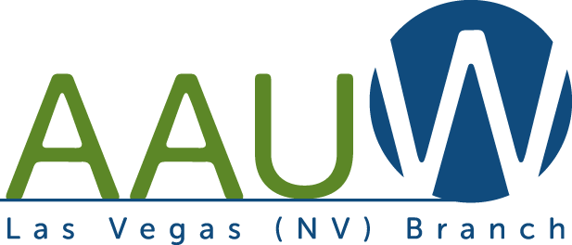

SCHOLARSHIP APPLICATION
2022-2023

The scholarship program of the Las Vegas branch of the American Association of University Women recognizes and supports education for women. One or more scholarships will be available for the upcoming academic year to aid the advancement of women’s educational and career goals.
Eligible applicants must meet the following criteria:

- Full time female student at Nevada State College or
  - Full time female student at UNLV majoring in a science field
- Must be a junior or senior (minimum 60 Credit hours)
- Have and maintain a GPA of 3.0 or better
- Have financial need
- Demonstrated desire to help others in the community
- Involved in extracurricular activities
- Submit a completed application and all required documentation by the deadline, June 10, 2022.

Awards:
Scholarship funds may be applied toward tuition, school fees, and/or required textbooks. The award will be provided after evidence of full-time enrollment and 3.0 GPA have been received.
Those who are awarded scholarships will also be given a Student Affiliate Membership in the Las Vegas Branch. Recipients will be guests of the Las Vegas Branch at a meeting.

How to apply
All information must be submitted as Word or PDF files.
Prepare an application package containing the following:
(1) Applicant’s general information page (attached)
(2) Certifications and authorizations page (attached)
(3) Typed personal statement page of 650 words or less which answers these questions:
(a) What are your educational goals?
(b) What are your career goals?
(c) Why do you need a scholarship?
(d) What difficulties have you faced and handled while working towards your educational goals?
(4) Two letters of recommendation (teachers, counselors, employers) sent directly from the recommender to aauwlasvegas@gmail.com
(5) Copy of transcript(s) and any test scores you want to provide
(6) Listing of awards, extracurricular activities, leadership positions, employment history (including dates), and highlights of community service

Deadline
Applications must be submitted no later than June 10, 2022 to: aauwlasvegas@gmail.com

AAUW Mission Statement

To advance gender equity for women and girls through research, education, and advocacy.

Questions:

If you have any questions, please contact us at aauwlasvegas@gmail.com

SCHOLARSHIP APPLICANT GENERAL INFORMATION PAGE

Name _________________________________________________________________
First Middle Last
Address______________________________________________________
City_________________________________ State______________ Zip___________
Home Phone________________________ Work Phone_______________________
Cell Phone ___________________
Email Address (Type or Print Clearly)_____________________________________
Cumulative Grade Point Average through the spring 2021 semester ______________(minimum 3.0 to qualify for consideration)
College attended in 2020-2021_____________________________________________
College you will attend for the upcoming fall semester_________________
I will be a junior____ senior_____ in the fall.
Expected date of graduation______________________
Degree you are pursuing__________________________
List ALL scholarships, grants, and financial awards I have received for the upcoming academic year and the dollar amounts of each: _______________________________________________________________________
_______________________________________________________________________
_______________________________________________________________________
_______________________________________________________________________

___________________________________________ ___________________________
Signature of Applicant Date
SCHOLARSHIP
CERTIFICATIONS AND AUTHORIZATIONS
All of the information in this application package is true and complete to the best of my knowledge. I certify that I will be a full-time junior or senior at ______________________. I hereby authorize the American Association of University Women, Las Vegas Branch to utilize information about my application and my likeness for publicity and public relations purposes.

_________________________________________ ________________
Signature Date

I understand that if I do not achieve junior or senior status by the upcoming fall, I will forfeit this scholarship should it be awarded to me. I also agree that all parts of the application are retained as property of the Las Vegas Branch of AAUW. I understand that I must maintain full-time status for the academic year and that I must maintain a 3.0 grade-point average.

________________________________________ ________________
Signature Date

AUTHORIZATION FOR RELEASE OF RECORDS
To comply with the provisions of the Family Education Rights and Privacy Act of 1974, permission is hereby given to school officials to release the school records and other requested information for consideration in the American Association of University Women, Las Vegas Branch Scholarship.

_______________________________________ ___________________
Signature Date

