Helen J. Stewart Statue Dedication

December 3, 2011 12-1 pm. Old Las Vegas Mormon Fort State Historical Park

Presented by Friends of the Fort



Meet Government officials, Family members, Ben Victor Sculptor and Dr. Linda Miller

(Helen J. Stewart Interpreter) and preview of Documentary by Gwen Clancy:

Life and Times of Helen J. Stewart: the Legacy Lives On

Refreshments Following Program

Funding from Las Vegas Centennial Commission for Statue and Documentary

And Partial Funding from Nevada Humanities for Documentary

RSVP at [friendsofthefort@yahoo.com](mailto:friendsofthefort@yahoo.com) or call 486-3511 by Nov. 25, 2011

$1 State Park Fee Waived thanks to Cultural Corridor Grant

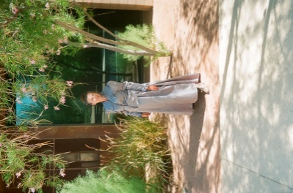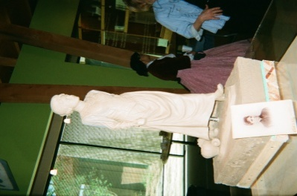

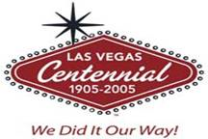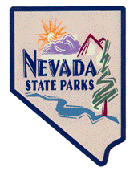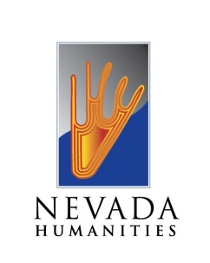

AAUW Members

You are invited to celebrate the statue dedication of Helen J. Stewart, one of the first college educated women to arrive in the Las Vegas Valley in 1882. Helen J. Stewart, often called “The First Lady of Las Vegas” because of her civic accomplishments, will have a statue dedicated to her near her former home, now the grounds of the Old Las Vegas Mormon Fort State Historic Park at the southeast corner of Washington and Las Vegas Boulevard.

Helen graduated from Woodland College in Yolo County California. Then she soon married Archibald Stewart and they moved to his ranch in Pony Springs in 1873. They moved to the Las Vegas Valley in 1882 after the Stewarts acquired foreclosed property from business associate O.D. Gass. After the death of her husband in 1884, Helen ran the ranch along with her five children and father.

In 1902 Helen sold over 1800 acres to Senator Clark of Montana who had ties to the railroad. She became a civic leader founding many organizations.

The Friends of the Fort, a non-profit organization that works with the Old Las Vegas Mormon Fort State Historic Park, applied for and was awarded $99,000 by the Las Vegas Centennial Commission on July 26, 2010 to fund the statue of Helen Stewart. Sculptor Benjamin Victor was chosen to design and create the statue. A documentary chronicling her life will also be produced by Gwendolyn Clancy from Reno. It will be available for viewing at the Old Fort and for distribution to schools.

Dr. Linda Miller, AAUW member, has been recreating the life of Helen J. Stewart through first person interpretation around the community to raise public awareness. On April 9, 2011 she presented Helen at our state conference.

On December 3, 2011, join government officials, family members of Helen Stewart and civic leaders reflecting on the organizations on which she made an impact. The dedication of the statue with a preview of the documentary begins at 12 pm with light refreshments to follow.

To RSVP call the Old Fort at 486-3511 or email [friendsofthefort@yahoo.com](mailto:friendsofthefort@yahoo.com) by November 25.