Examining Primary Sources About Helen Stewart
Prepared by Dr. Linda Karen Miller
Procedure: Students will examine the following primary sources to evaluate the contributions of Helen J. Stewart, the founding mother of Las Vegas. Students will also complete the appropriate activity sheets for the documents. The statue of Helen J. Stewart at the Old Las Vegas Mormon Fort State Historic Park will be used to examine artifacts depicting her contributions.
Resource for Documents: “The Letters of Helen J. Stewart”, Nevada State Museum, Las Vegas, 2009.
7.5 Students will summarize the contributions of the diverse populations of Nevada’s early settlers by utilizing one of the Big 11 Social Studies Skills.
Analyzing Primary Sources:
How to Analyze a text:
- Determine the type of document. Is it a letter, an official proclamation, a private diary entry, an advertisement or perhaps a coded message?
- Why do you think the document was written?
- What evidence in the document helps you know why it was written?
- Is there a bias or certain perspective that the author is writing from?

Document Analysis Grid
Big Question Being Addressed: What I already know:
Name of Document Source
Primary Source Author
Secondary Source Date
Main Idea of Document Key Information/quotation and
Location of information:
Discussion Web
A Discussion webs helps students visualize the key elements of an issue and quickly indentify opposing points of view.
YES REASONS NO
QUESTION: Why should Helen J. Stewart be called the “First Lady Of Las Vegas”?
Conclusion:
Understanding Newspaper Articles
Title and Date of Article:
Where does the story take place?
What is the lead of this article?
What is the type of lead? (create an impact, reveal a quote, ask a question, and indirect)
Fill in the information about the details of the article:
Important details to remember
WHO WHAT WHEN WHERE WHY/HOW
ANNOTATED TIMELINE
After reading all of the documents, create an annotated timeline of dates in Helen J. Stewart’s life. For each event, include information such as the names of the people involved, the actions that occurred and their significance. The annotations should be brief. Display the dates in a consistent manner.

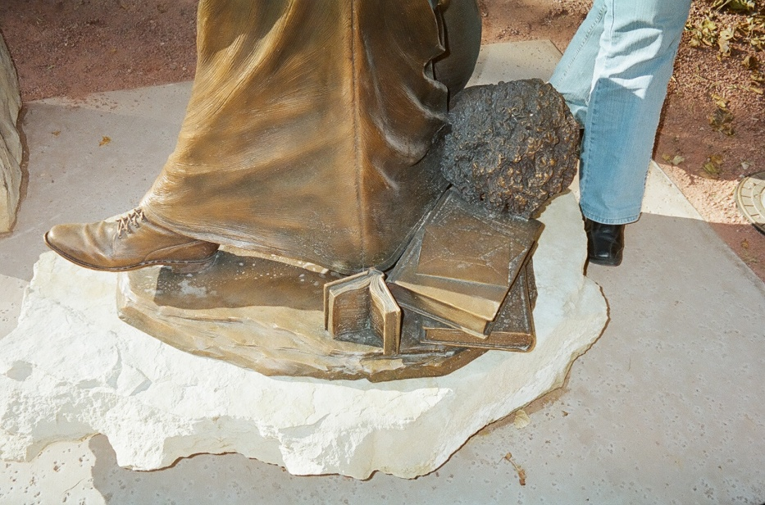
Close up of artifacts on Statue
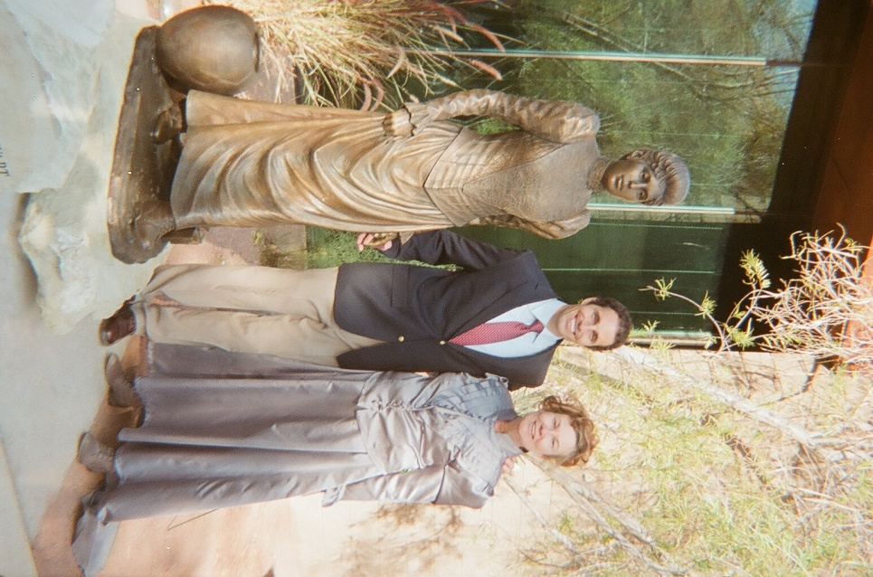
Benjamin Victor Sculptor with Dr. Linda Karen Miller, Helen Stewart interpreter and author of lesson plan.

Document 1
Congressional Record November 30, 2011
Proclaiming The State of Nevada Recognize Helen J. Stewart As “The First Lady of Las Vegas”. And Honor Her Statue Which Will Be Raised At The Old Las Vegas Mormon Fort State Historic Park On December 3, 2011 In Las Vegas, Nevada.
Hon. Mark E. Amodei of Nevada In the House of Representatives Wednesday November 30, 2011
Mr. Amodei. Mr. Speaker, I rise today to recognize Helen J. Stewart as “First Lady of Las Vegas”. And honor her statue which will be raised at the Old Las Vegas Mormon Fort State Historic Park on December 3, 2011 in Las Vegas Nevada.
Helen with her husband Archibald, three children and one on the way, arrived in the Las Vegas Valley in 1882 and resided on the land located around the abandoned Mormon Fort situated near what today is the intersection of Las Vegas Boulevard North and Washington Avenue. Later left with four children and another on the way after the death of her husband in 1884, she became a rancher and business woman and presided over the operations of the ranch. She began buying land and became the largest landowner in Lincoln County. She later sold her land to the railroad in 1902 and hence forth the city of Las Vegas developed.
As the new town expanded, Helen became active in the community serving in many leadership roles such as one of the founders of Christ Episcopal Church, charter member of the Mesquite Club, president of the Las Vegas branch of the Nevada Historical Society, supporter of women’s suffrage, first woman elected to the school board on the Republican ticket and as a friend to the Paiute Indians who worked on her ranch, sold ten acres of the land to the federal government to be used as an Indian school and semi-reservation which remains tribal land today.
ON July 26, 2010 the Historical Commission of the Las Vegas Centennial awarded the “Friends of the Fort” $99,000 for the Helen J. Stewart statue to be sculpted by Benjamin Victor of Aberdeen, South Dakota.
Both the State of Nevada and I recognize the statue of Helen J. Stewart to be a fitting recognition of the many “firsts” that this exceptional Nevada lady forever known as the “First Lady of Las Vegas” accomplished in her lifetime.
Document 2
Quarterly Statement up to Dec. 31 1893
Post office Los Vegas Nevada
March 15, 1894
Office of the Auditor of the Treasury
Hon John B. Brady
Dear Sir:
Yours of 28th February 1894 informing me of your receipt of Quarterly Statement ended Dec. 31st 1893 at hand. In answer would say sent in statement for Dec. 31st 1893 in this way.
New Office No Service No account to send in. If it should be different please let me know as this is all new to me and I do not understand. We are so far from any Post office. It takes a long time to get reply 50 miles by wagon road. Awaiting instructions. For a better understanding.
Yours truly Helen J. Stewart Postmaster Los Vegas Nevada
Document 3:
11/26/1897 clipping from the Los Angeles Record.
Youthful Liar
Is Twelve Year Old Archibald Stewart According to His Sisters
Started for Nevada
But only Reached Pasadena His Harrowing Tale Told to the Constabulary of the City –His Sisters Version
Archibald Stewart,k a 12 year old is according to his sisters, a prodigious liar. The sisters lie at 340 ½ South Hill Street.
Archibald was found wandering on the streets of Pasadena Thursday by the police crying and penniless. He was given his dinner by Marshal Lacey. He said he was on his way to Nevada. Whither his mother had gone a few days ago, leaving tickets for him and his 2 sisters.
They had pawned the tickets and lost the poawnbrokers ticket so could not recover the pasteboards.
Archie started to foot it. His mother he said, owned thousands of acres in Nevada.
The police notified his sisters, who took him home last night.
This morning they said: “it is true Archie was lost in Pasadena without money, but he had no intention of going to Nevada. He was taken to Pasadena by a friend, Mr. Peter Cochran but they had become separated and Archie was taken care of by the police.
“ it is true our mother recently went to Nevada where she owns considerable property but we had no expectation of follo9wing her as we are going to school here. Archie was very anxious to go east with mother, and rather spunky when he was not permitted to do so. That is all there is to it.”

Document 4
Department of the Interior
United States Indian Service
Fort McDermitt School, McDermitt, Nevada July 6, 1912
Mrs. Helen J. Stewart
Las Vegas Nevada
Dear Mrs. Stewart:
“The validity of the dead from Helen J. Stewart to the United States has been passed upon by the Department of Justice and in a letter from the Department dated April 17, 1912, a copy enclosed herewith, the opinion is expressed that, depending upon the facts set forth in the abstract of title the deed is sufficient to vest in the United States a good title to property described herein…
Document 5
Las Vegas Nevada. Jan. 12, 1914
My Darling Girlie…
I was elected a Delegate from our Mesquite Club to the Federation of Women’s Clubs to be held in Carson City, Nevada in the first week in October, Eva was taken sicjk and I could not go. It was too bad as the delegates were to be entertained at the Governors and many nice things were planned for them. We were to be given a Banquet at Goldfield. Tasker Oddie is now governor of the State of Nevada…Las Vegas as a Railroad town is a howling success and progressing. It is increasing in population and in values. …It is a good country to live in and invest in. I have four lots in town. For the first one I bought three years ago I paid $375. The second one I bought two years ago and paid $500…We have had a divorce cyclone strike out loved city….

Document 6
October 27, 1915
Goldfield Hotel, Goldfield Nevada
Here I am on my way to Speech making as a delegate from Las Vegas to Yerington Nevada. To the Federation of Womens Clubs. We will send you papers.
Loving Mama Helen J. Stewart
Im going on down to Galt. Eva Willie MR., Stewart Mina and baby are well HJS
Document 7
Las Vegas Nevada
December 2, 1916
Dear Tiza
We are all quite well… I have been elected President of our Mesquite Club, also nominated by the Republican Ticket as one of the Board of Education. Endorsed by the Democrats and elected by all my friends. I have also just received a commission from Governor Emmet Boyle as one of the Delegates to the Twelfth Annual Convention of the American Civic Association to be held in Washington, D.C. at the New Willard Hotel December 13th and 14th and 15th 1916. It is quite an honor and I had plenty of money I would sure go…
Document 8
State of Nevada
Executive Chamber
Carson City
December 5, 1918
Mrs. Helen J. Stewart
Las Vegas, Nevada
My dear Mrs. Stewart,
I am most deeply grateful for your card of congratulations which reached me only today and I sincerely trust I will be able to live up to all the expectations of my kind friends in Nevada.
I look forward, as one of the most pleasant functions of my office to the entertainment of you in Carson City again, and Mrs. Boyle and myself hope that this pleasure will come to us at no greatly deferred date.
With all kind wishes,
I remain
Most sincerely yours
Emmet Boyle

Document 9
Las Vegas Nevada
October 14, 1919
Dear Tiza
Your promised letter has not come yet…There has been Coal Oil found near the Charleston Mountains on the west said and everybody that can is slipping out of town quietly and looking for oil. There has been found oil indications near some of my land and when I get a gusher I am coming right back after you…Do you remember the Mastodon Bones we found between tule and Corn Creek. The other day we found a spring near Tule some black stuff that looked good….If men that are hunting for oil now find a seepage there will be a big oil bo9om here….
Lovenly Mamma
Document 10
Las Vegas Nevada
June 8th 1920
Dear Tiza…
I believe I will take the desert any day and again we are just about as up to date as any place in the good old US yesterday passengers were going to and from Kiel ranch all day in a flying machine…Talk about tobacco and rice and cotton. We have planted and growing in our valley now over 400 acres of Cotton …wait until they have the Colorado River harnessed to a big Dam which they are now surveying. In fact men are there now working; and soon the project will materialize and we will be supplied with sufficient power to run all the pumping plants we can install..This southern Nevada has a promise of a wonderful future; …Your mamma being clerk of the High school board and the first woman in Clark County to be elected to that Office…
Lovingly mamma
Document 11
Las Vegas Nevada
November 18, 1920
Dear Tiza,
…I sent you Las Vegas age along with the election returns; Will was elected long term commissioner by an overwhelming majority; We were proud of the way his friends stood by him and glad that Will could have a chance to prove the metal that was in him. Will is going out to the mines today to do some assessment work; we have a sale on for our gypsum of twelve though dollar…we have waited for so many mining deals to prove themselves…
Lovinginly Mamma
Document 12
Las Vegas Nevada
February 7, 1922
Darling girlie:
The 23rd of January I was summoned on the jury which lasted a little over two weeks…I served on the 1st case a murder case. Judge Orr a former Pioche man was one judge. Harley Harmon and Stevens were for the state and a young man from Los Angeles by name of Hinman was for the defendant. After five days and with the judge and lawyers, the jury of 8 men and 4 women retired to the jury room and after five hours and 55 minutes returned a verdict of involuntary manslaughter…we were treated to fine first class accommodations .fine room and nice new single beds and bedding and three meals a day at the best restaurant in town..the Las Vegas…
With love from Mamma
Document 13
Las Vegas Nevada
May 15, 1924
Dear Tiza
Our town and the space between here and the Colorado Boulder Cannon Dam are the scene of much excitement today. Uncle Sam’s Navy boys from the Battle ship are the guests of the Legion boys and the city of Las Vegas. Quite an honor for Las Vegas and the boys from the Navie….
Your loving Mamma
Document 14
State of Nevada
Executive Chamber
Carson City
February 24, 1925
Mrs. Helen Stewart
Las Vegas, Nevada
Dear Mrs. Stewart:
In connection with the proposed Exposition to be held in Reno in 1926, it occurred to me that it would be desirable to have your collection of baskets and Nevada relics available for display.
It is possible that the legislature may be willing to pass an act permitting the appropriation of a moderate sum of money for the purpose of purchasing your collection in order that it may be permanently kept on exhibit within the state. While the proposal is only tentative I write to inquire as to the lowest figure you would be willing to sell the collection for the use of the Nevada Historical Society.
With regards I am
Yours truly,
J.G. Scrugham
Governor
Document 15
Las Vegas, Nevada March 10, 1925
To His Excellency
J.G. Scrugham
Kind Friend:
I feel honored to receive a letter from our Governor, and that he is interested in my collection of Baskets gives me pleasure. A reply was due you earlier, but having had the flue and other members of my family sick I was unable to write to anyone.
In regards to the value of the Baskets I think you have traveled over this good old U.S. and having seen many Art Collections would be better able to decide their value than i.
The fact that you have personally viewed most of thaem would give you a better right to appraise them; I should fell much pleased to see them exhibited by the State; If they should decide to buy them, or exhibited under my own personal supervision, if it could be so arranged.
I regretted very much that your hurried visit to The Wonderful Buried City prevented your calling.
The young man MR. Shelleach brought me the specimen which you so kindly had framed I thank you ever so much. Trusting to hear from you soon with Kind Regards to Mrs. Scrugham.
Yours Sincerely Helen J. Stewart

